Name : Vivek Singh
RegNumber : 230905408
Roll Number: A50

Lab 3: HW

Q1) Design an attractive ‘train ticket booking form’ using different bootstrap elements.

<!DOCTYPE html>
<html lang="en">
<head>
<meta charset="UTF-8">
<title>Train Ticket Booking</title>
<link href="https://cdn.jsdelivr.net/npm/bootstrap@5.3.2/dist/css/bootstrap.min.css" rel="stylesheet">
</head>
<body class="bg-light">

<div class="container mt-5">
<div class="card shadow">
<div class="card-header text-center bg-primary text-white">
<h4>Train Ticket Booking</h4>
</div>

<div class="card-body">
<form>
<div class="row mb-3">
<div class="col">
<label class="form-label">From</label>
<input type="text" class="form-control" placeholder="Source">
</div>
<div class="col">
<label class="form-label">To</label>
<input type="text" class="form-control" placeholder="Destination">
</div>
</div>

<div class="row mb-3">
<div class="col">
<label class="form-label">Journey Date</label>
<input type="date" class="form-control">
</div>
<div class="col">
<label class="form-label">Class</label>
<select class="form-select">
<option>General</option>
<option>Sleeper</option>
<option>AC</option>
</select>
</div>
</div>

<div class="mb-3">
<label class="form-label">Passenger Name</label>
<input type="text" class="form-control">
</div>

<div class="text-center">
<button class="btn btn-success">Book Ticket</button>
</div>
</form>
</div>
</div>
</div>

</body>
</html>

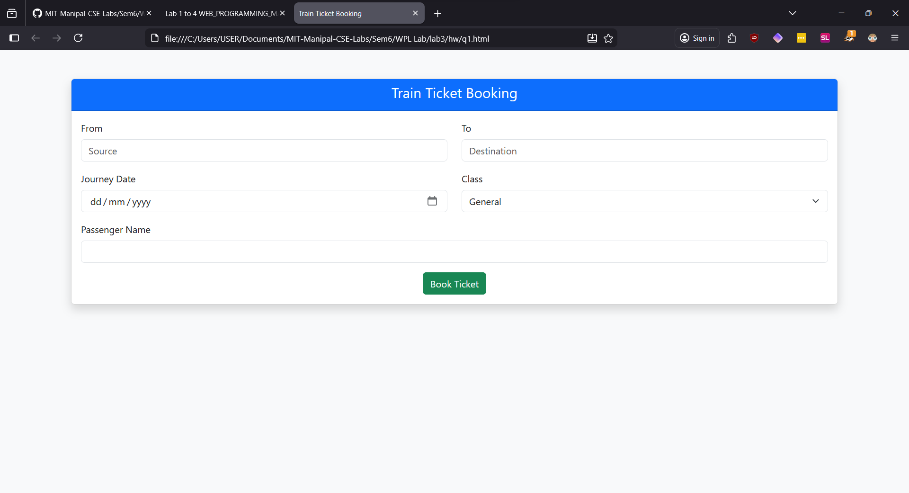

Q2) Design an attractive ‘magazine cover page’ using different bootstrap elements.
